Git Hands-on 4: Merge Conflict Resolution
Objective
Simulate a merge conflict between master/main and a branch, resolve it, and commit the changes.

1. Prerequisites
- Git installed and configured.
- Local repository at C:\Users\choll\GitDemo.
- P4Merge installed (optional for visual diff).

2. Steps
1. Verify master/main is clean
cd /c/Users/choll/GitDemo
git checkout main
git status
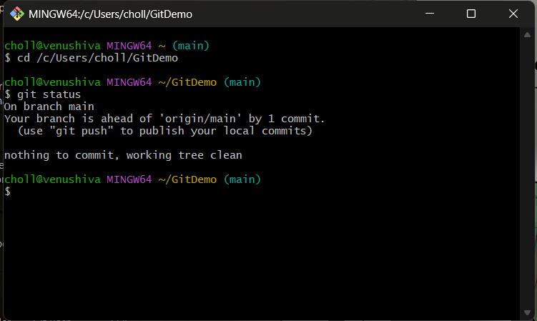

2. Create and switch to branch GitWork
git branch GitWork
git checkout GitWork
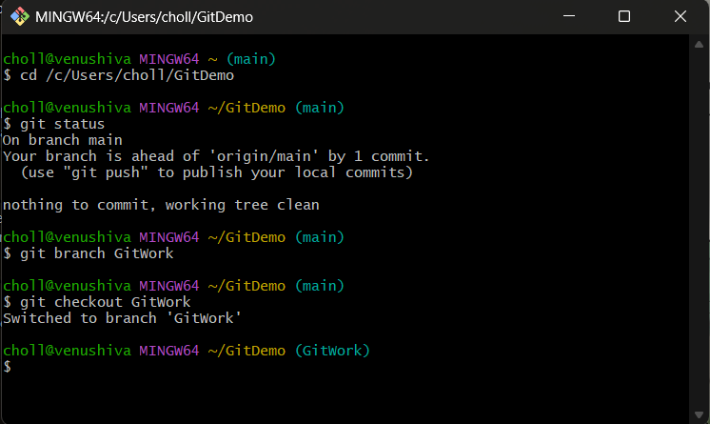

3. Add hello.xml in GitWork
echo "<message>Hello from GitWork branch</message>" > hello.xml
git add hello.xml
git commit -m "Add hello.xml in GitWork branch"
git status
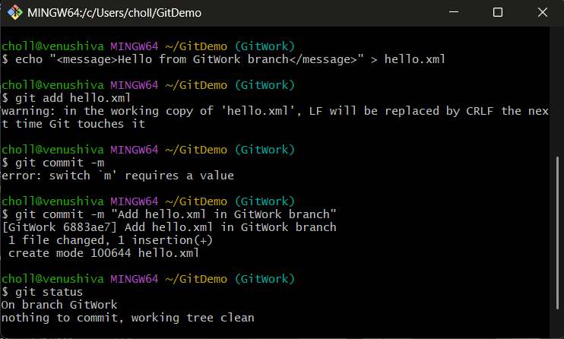

4. Switch back to master/main
git checkout main
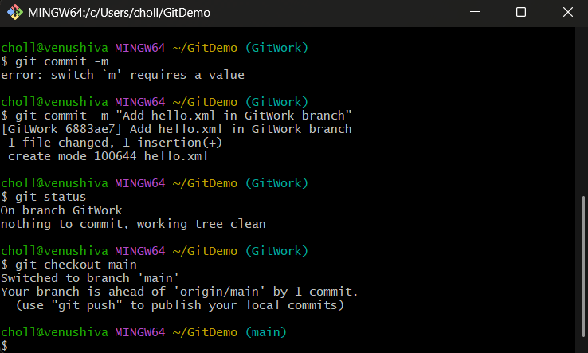

5. Add a different hello.xml in master/main
echo "<message>Hello from master branch</message>" > hello.xml
git add hello.xml
git commit -m "Add hello.xml in master branch with different content"
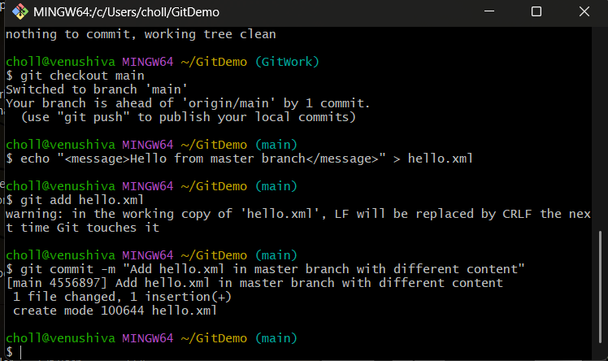

6. View commit history (all branches)
git log --oneline --graph --decorate --all
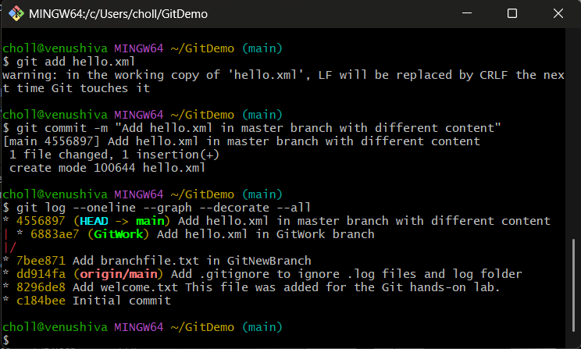

7. Show differences before merge
git diff main GitWork
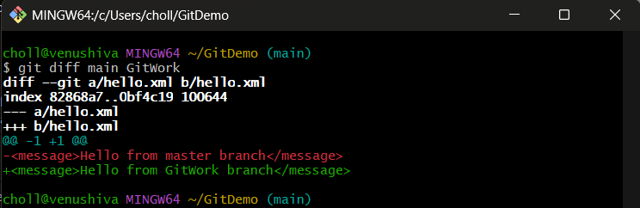

8. Merge GitWork into master/main (expect conflict)
git merge GitWork
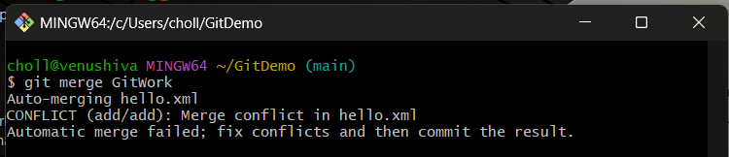

9. Resolve conflict
Edit hello.xml to desired final content:
<message>Hello from both branches</message>
Save the file.

10. Stage and commit resolved file
git add hello.xml
git commit -m "Resolve merge conflict in hello.xml"
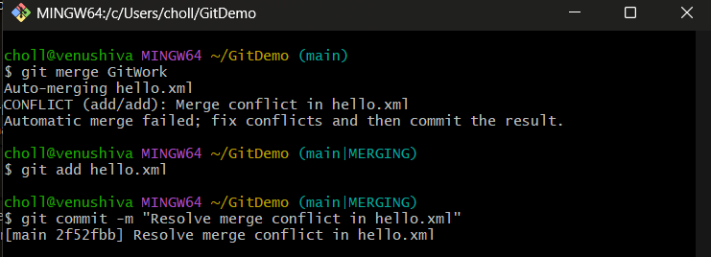

11. List and delete branch
git branch -a
git branch -d GitWork
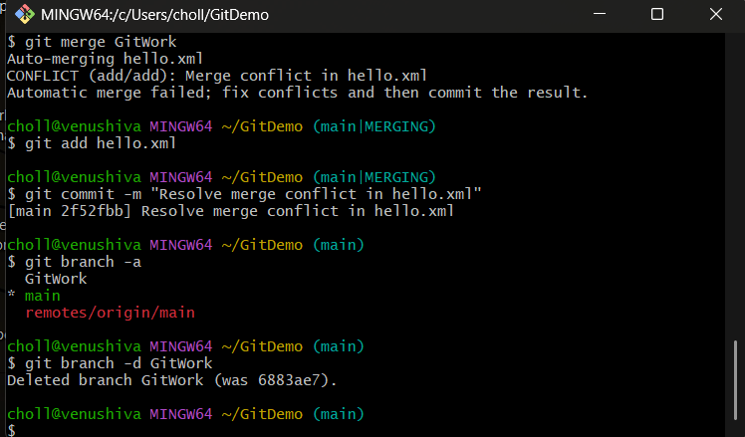

12. Final log and status
git log --oneline --graph --decorate
git status
